**COLEGIO DE MONTALBAN**

**INSTITUTE OF COMPUTER STUDIES**

**WEB FLOWCHART**

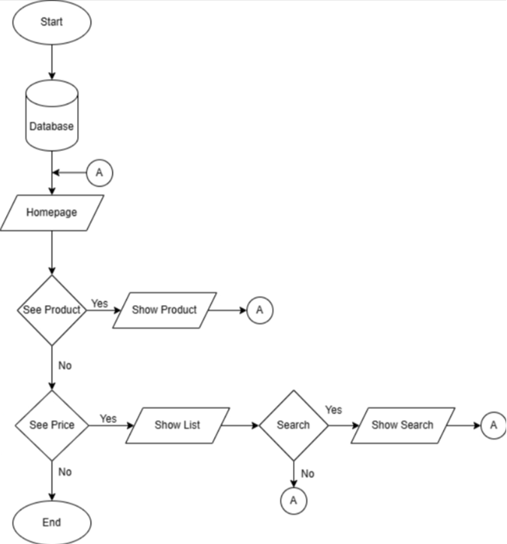

**PREPARED BY: JULIE ANN QUILBIO CHECKED BY: MARJON D. UMBAY**

**INFORMATION TECHNOLOGY INFORMATION TECHNOLOGY INFORMATION TECHNOLOGY INFORMATION TECHNOLOGY INFORMATION TECHNOLOGY INFORMATION TECHNOLOGY INFORMATION TECHNOLOGY INFORMATION TECHNOLOGY INFORMATION TECHNOLOGY INFORMATION TECHNOLOGY INFORMATION TECHNOLOGY INFORMATION TECHNOLOGY INFORMATION TECHNOLOGY INFORMATION**